**SAMPLE FOOD/FUND DRIVE MESSAGING***Use the sample messaging below in your social media and email outreach!***ABOUT THE OTTAWA FOOD BANK:  
  
HOW YOUR DONATION HELPS THE OTTAWA FOOD BANK:**The Ottawa Food Bank wants to not only provide food for people but provide the most nutritious food possible. Your financial donation helps the Ottawa Food Bank purchase the expensive and necessary items that everyone needs and deserves such as: fresh fruits and vegetables, dairy, grains, sources of protein as well as much-needed diapers. The Ottawa Food Bank provides this food to over 46,000 people every month with the help of the network of 98 emergency food programs across the city. Thank you for supporting the Ottawa Food Bank – we could not do it without you.  
**YOUR IMPACT:**

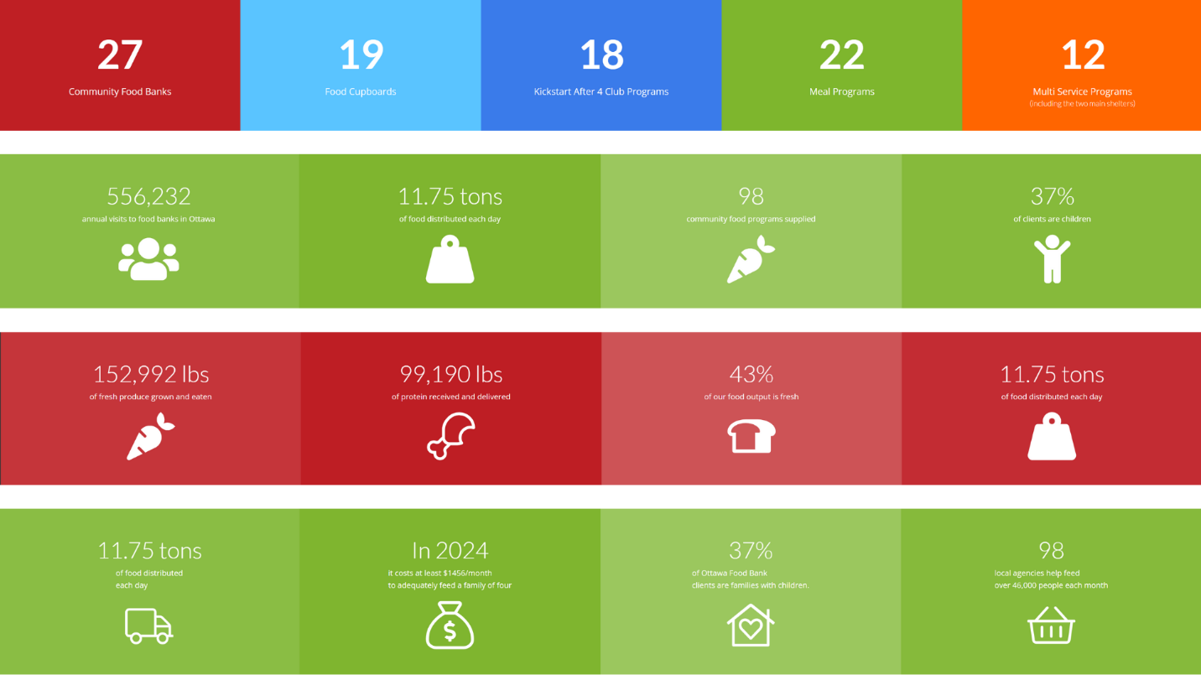  
  
 **SAMPLE EMAILS:** Dear [NAME],  
  
Please join me/us in supporting the Ottawa Food Bank! The Ottawa Food Bank delivers fresh, nutritious food to the network of 98 community food programs throughout Ottawa. These frontline programs provide choice and address the dietary needs of the 46,000 people who access a community food bank every month.  
  
Here's who we’re helping:   
  
It costs $336 to fill a family’s fridge for a week. Let’s see how many fridges we can fill together!  
  
Click on DONATE now and make an impact!

**SAMPLE SOCIAL MEDIA POSTS:**  
Help me/us fill fridges for the @OttawaFoodBank on (insert date and time) at (insert location)!! Every donation puts fresh, nutritious food back into the community. (insert donation page link)  
  
Add this information, if you’re also hosting a food drive:   
  
[FOOD DRIVE POSTERS - Refresh (Print) (11 x 17 in)](https://www.ottawafoodbank.ca/wp-content/uploads/2025/05/EN-Food-Drive-Poster-11x17-1.pdf)  
[FOOD DRIVE POSTERS - Refresh (Print)](https://www.ottawafoodbank.ca/wp-content/uploads/2025/05/EN-Food-Drive-Poster-8.5x11.pdf)

**NOTE FROM THE OTTAWA FOOD BANK**

You know your audience best, so feel free to create your own messaging. If you do, be sure to tag @OttawaFoodBank and use hashtags to tell people about your event and get more engagement.